UNIVERSITY OF WAH (UOW)

DEPARTMENT OF COMPUTER SCIENCE



BSCS 3RD B

REG #: UW-24-CS-BS-088

SUBMITTED BY: SAADI SAFDAR

SUBMITTED TO: Ms. MUNIBA KHAN

COURSE TITLE: DATA STRUCTURES

COURSE CODE: CS – 201 L

LAB REPORT # 14

Assigned tasks in lab.

1. Depth First Search (DFS)

#include <iostream>
#include <vector>
#include <map>

using namespace std;

void dfs(char node, map<char, vector<char>> graph, map<char, bool> visited) {
visited[node] = true;
cout << node;
for (char neighbor : graph[node]) {
if (!visited[neighbor]) {
dfs(neighbor, graph, visited);
}
}
}

int main() {
map<char, vector<char>> graph;
graph['A'] = {'B', 'C'};
graph['B'] = {'D'};
graph['C'] = {'E'};
graph['D'] = {};
graph['E'] = {};
map<char, bool> visited;
cout << "DFS Traversal: ";
dfs('A', graph, visited);
return 0;
}
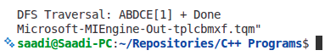

2. Insertion Sort

#include <iostream>

using namespace std;

void insertionSort(int arr[], int n) {
for (int i = 1; i < n; i++) {
int key = arr[i];
int j = i - 1;
while (j >= 0 && arr[j] > key) {
arr[j + 1] = arr[j];
j--;
}
arr[j + 1] = key;
}
}

int main() {
int arr[] = {8, 3, 5, 2};
int n = 4;
insertionSort(arr, n);
cout << "Sorted Array: ";
for (int i = 0; i < n; i++) {
cout << arr[i];
}
return 0;
}
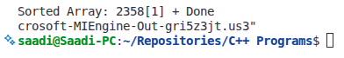
3. Quick Sort

#include <iostream>

using namespace std;

int partition(int arr[], int low, int high) {
int pivot = arr[high];
int i = low - 1;
for (int j = low; j < high; j++) {
if (arr[j] < pivot) {
i++;
swap(arr[i], arr[j]);
}
}
swap(arr[i + 1], arr[high]);
return i + 1;
}

void quickSort(int arr[], int low, int high) {
if (low < high) {
int pi = partition(arr, low, high);
quickSort(arr, low, pi - 1);
quickSort(arr, pi + 1, high);
}
}

int main() {
int arr[] = {10, 7, 8, 9, 1, 5};
int n = 6;
quickSort(arr, 0, n - 1);
cout << "Sorted Array: ";
for (int i = 0; i < n; i++) {
cout << arr[i];
}
return 0;
}
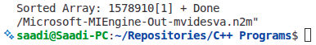

Lab Tasks for Students: Student Practical & Scenario-Based Tasks

Task 1: DFS Traversal – Real Scenario A college campus has different departments connected by pathways. Represent the departments as vertices and pathways as edges using an adjacency list. Implement Depth First Search (DFS) to traverse all departments starting from the main gate.

#include <iostream>
#include <vector>
#include <map>

using namespace std;

void dfs(char node, map<char, vector<char>>& graph, map<char, bool>& visited) {
visited[node] = true;
cout << node << " ";
for (char neighbor : graph[node]) {
if (!visited[neighbor]) {
dfs(neighbor, graph, visited);
}
}
}

int main() {
map<char, vector<char>> graph;
graph['M'] = {'C', 'L'}; // Main Gate -> Computer Lab, Library
graph['C'] = {'A', 'E'}; // Computer Lab -> Admin, Engineering
graph['L'] = {'S'}; // Library -> Science
graph['A'] = {}; // Admin
graph['E'] = {}; // Engineering
graph['S'] = {}; // Science
map<char, bool> visited;
cout << "Campus DFS from Main Gate: ";
dfs('M', graph, visited);
cout << endl;
return 0;
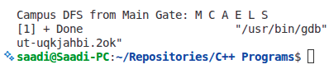
}

Task 2: DFS for Website Navigation A website consists of multiple web pages linked together. Write a C++ program using DFS to simulate visiting all web pages starting from the home page. Display the order in which pages are visited.

#include <iostream>
#include <vector>
#include <map>

using namespace std;

void dfs(string node, map<string, vector<string>>& graph, map<string, bool>& visited) {
visited[node] = true;
cout << node << " ";
for (string neighbor : graph[node]) {
if (!visited[neighbor]) {
dfs(neighbor, graph, visited);
}
}
}

int main() {
map<string, vector<string>> graph;
graph["Home"] = {"About", "Products"};
graph["About"] = {"Contact", "Team"};
graph["Products"] = {"Pricing", "Support"};
graph["Contact"] = {};
graph["Team"] = {};
graph["Pricing"] = {};
graph["Support"] = {};
map<string, bool> visited;
cout << "Website visit order: ";
dfs("Home", graph, visited);
cout << endl;
return 0;
}
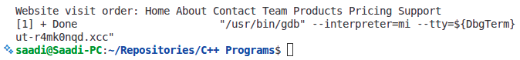

Task 3: Insertion Sort for Student Marks An array stores marks of students obtained in a class test. Implement Insertion Sort to arrange the marks in ascending order. Display the array after each pass of sorting.

#include <iostream>

using namespace std;

void insertionSort(int arr[], int n) {
for (int i = 1; i < n; i++) {
int key = arr[i];
int j = i - 1;
while (j >= 0 && arr[j] > key) {
arr[j + 1] = arr[j];
j--;
}
arr[j + 1] = key;
// Display after each pass
cout << "After pass " << i << ": ";
for (int k = 0; k < n; k++) {
cout << arr[k] << " ";
}
cout << endl;
}
}

int main() {
int marks[] = {85, 92, 78, 95, 88, 76};
int n = 6;
cout << "Student marks sorting:" << endl;
insertionSort(marks, n);
return 0;
}
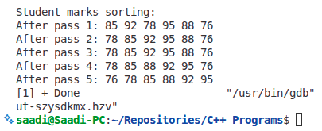

Task 4: Quick Sort for Online Product Prices An online shopping platform stores product prices in an array. Use Quick Sort with the last element as pivot to sort the prices. Show the final sorted list of prices.

#include <iostream>

using namespace std;

int partition(int arr[], int low, int high) {
int pivot = arr[high];
int i = low - 1;
for (int j = low; j < high; j++) {
if (arr[j] < pivot) {
i++;
swap(arr[i], arr[j]);
}
}
swap(arr[i + 1], arr[high]);
return i + 1;
}

void quickSort(int arr[], int low, int high) {
if (low < high) {
int pi = partition(arr, low, high);
quickSort(arr, low, pi - 1);
quickSort(arr, pi + 1, high);
}
}

int main() {
int prices[] = {299, 1500, 799, 450, 1200, 99, 899};
int n = 7;
cout << "Original prices: ";
for (int i = 0; i < n; i++) cout << prices[i] << " ";
cout << endl;
quickSort(prices, 0, n - 1);
cout << "Sorted prices: ";
for (int i = 0; i < n; i++) cout << prices[i] << " ";
cout << endl;
return 0;
}
